Background Image (for entire site)


(Storyboard A) Home Page | Navigation Details  - Red home menu (at top & bottom) links to new pages  - Search bar at top left searches entire site  - Black side menu consists of buttons that link to new pages  - Red buttons link to new pages  - Latest art lesson page  - Art supplies page  - How To Draw eBooks page  - Black side menu  - consists of buttons that link to new pages when clicked  - When users hover over a button, its subcategories (if applicable) will appear, and they can be clicked on and it will link to that subcategory’s page (the same function as current design; you can hover over How To Draw and see animals, buildings, etc, then hover over animals and can see birds, cats, etc)
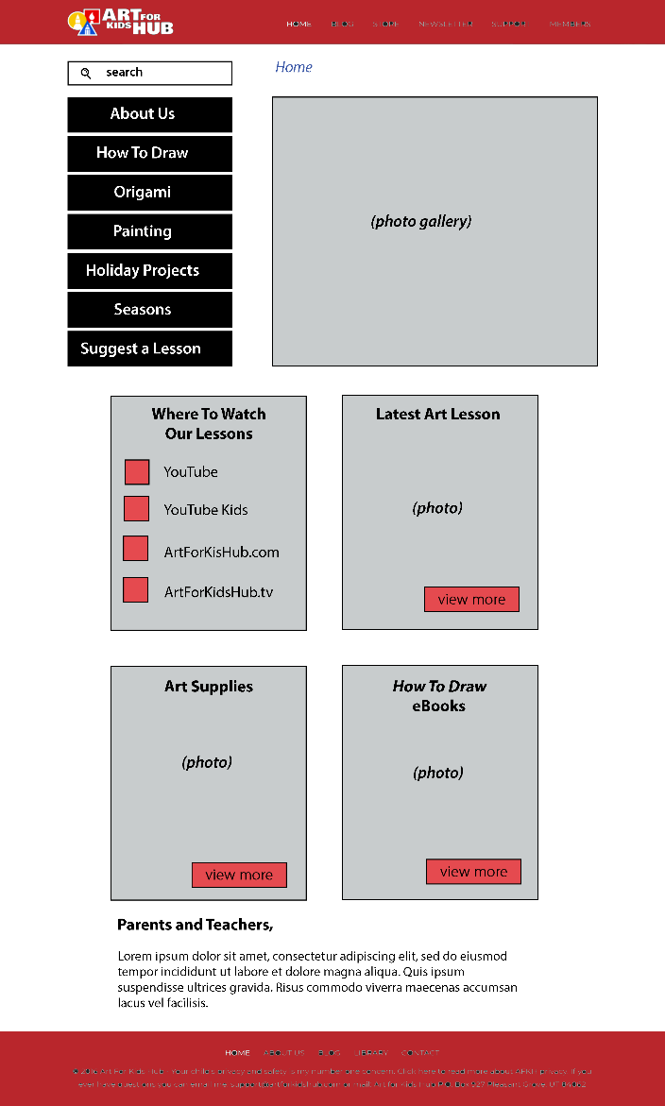

Multimedia Notes
- Background image for entire site is the black colored pencil/marker image
- Gray rectangle at top will contain an automatically moving photo gallery of photos of various artwork
- Red squares under ‘where to watch our lessons’ will be clickable icons (youtube icon, etc)
- Each of the 4 gray rectangles will contain a background photo that represents that category
- No narration, no audio

(Storyboard B) About Us Page | Navigation Details  - Red home menu (at top & bottom) links to new pages  - Search bar at top left searches entire site  - Navigation text at top is clickable, (Home/About Us) users can go back to home by clicking Home  - Clicking the Art For Kids Hub logo links back to Home page
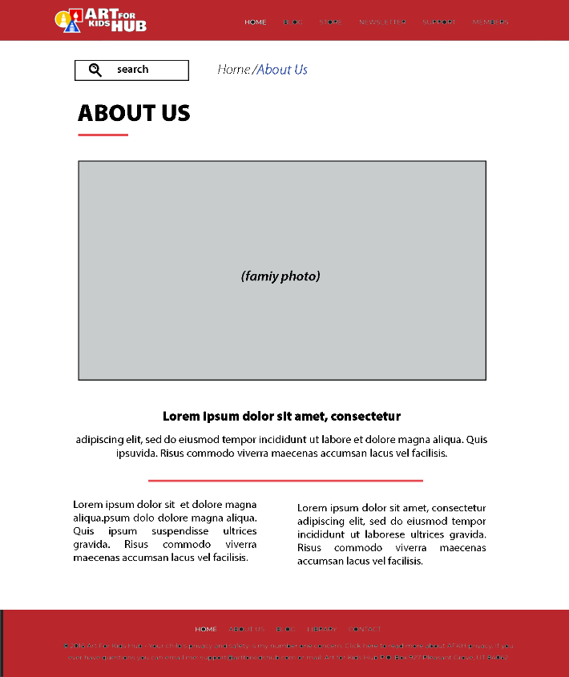

Multimedia Notes
- Background image for entire site is the black colored pencil/marker image
- Gray rectangle will contain photo of family
- no narration, no audio

(Storyboard C) Suggest a Lesson Page | Navigation Details  - Red home menu (at top & bottom) links to new pages  - Search bar at top left searches entire site  - Navigation text at top is clickable, (Home/About Us) users can go back to home by clicking Home  - Clicking the Art For Kids Hub logo links back to Home page
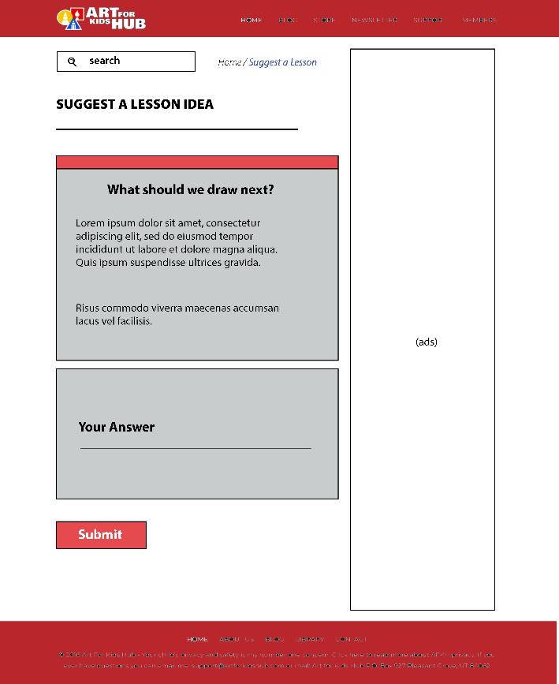

Multimedia Notes
- Background image for entire site is the black colored pencil/marker image
- Company logo at top left
- interaction in the text answer box to submit feedback with submit button
- (current page design contains ads on the right, OK for new design)
- No narration, no audio

(Storyboard D) Art Supplies Page | Navigation Details  - Red home menu (at top & bottom) links to new pages  - Search bar at top left searches entire site  - Navigation text at top is clickable, (Home/Art Supplies) users can go back to home by clicking Home  - Clicking the Art For Kids Hub logo links back to Home page  - Black menu on right side contains clickable buttons that when clicked, jumps users to that part of the screen so they don’t have to scroll  - List of links on the left in each section are clickable and link to outside sites  - Back to Top text at the top of each section can be clicked and brings user back to the top of the screen (to reduce scrolling)
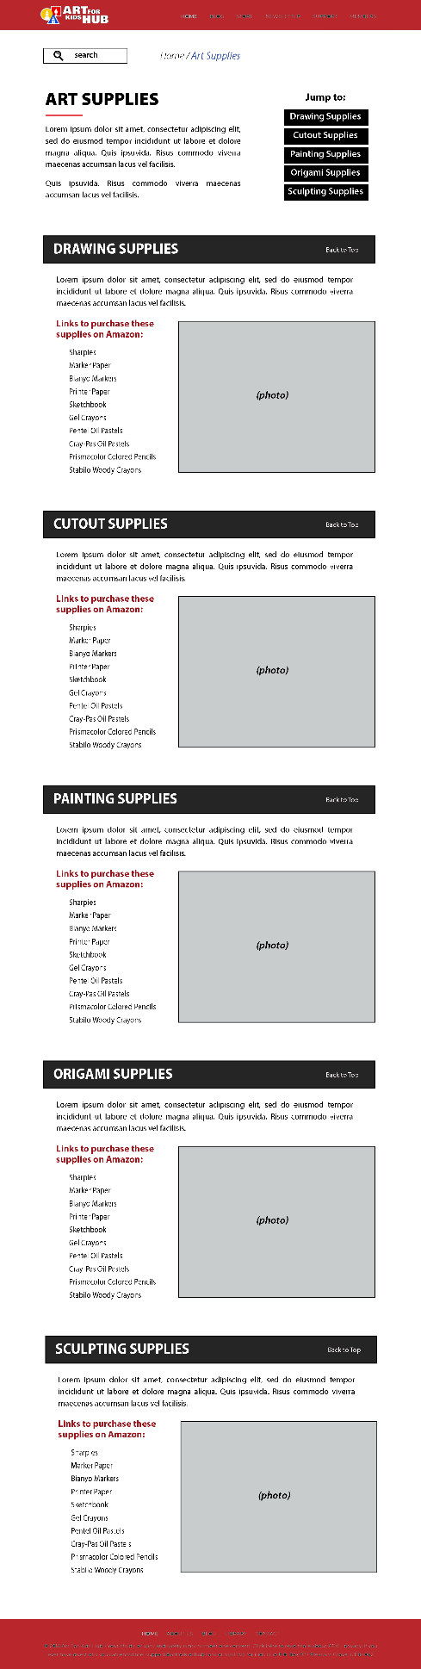

Multimedia Notes
- Background image for entire site is the black colored pencil/marker image
- Company logo at top left
- Gray rectangles will contain same images from current webpage for each section
- Drawing supplies image
- Cutout supplies image
- Painting supplies image
- Origami supplies image
- Sculpting supplies image
- No narration, no audio

(Storyboard E) How To Draw Page | Navigation Details  - Red home menu (at top & bottom) links to new pages  - Search bar at top left searches entire site  - Navigation text at top is clickable, (Home/ How To Draw) users can go back to home by clicking Home  - Clicking the Art For Kids Hub logo links back to Home page  - Black side menu:  - consists of buttons that link to new pages when clicked  - When users hover over a button, its subcategories (if applicable) will appear, and they can be clicked on and it will link to that subcategory’s page (the same function as current design; you can hover over animals and can see birds, cats, etc which are then clickable)  - Clicking on Latest Art Lesson text, red box, and video thumbnail all lead to latest art lesson page  - The title of each section (animals, buildings, characters, food, etc) can be clicked and it will link to that category’s main page. The “Go To xx Page” buttons also perform the same function.  - Categories with subcategories (animals, characters, & food) contain a list of those subcategories within its section. When the user hovers over the word, like bird, the photo gallery on the right will display thumbnails for videos of bird drawing lessons. When the user clicks on the word, they will be redirected to the lessons gallery page for that category.  - “Back to Top” text at the top of each section can be clicked and brings user back to the top of the screen (to reduce scrolling)
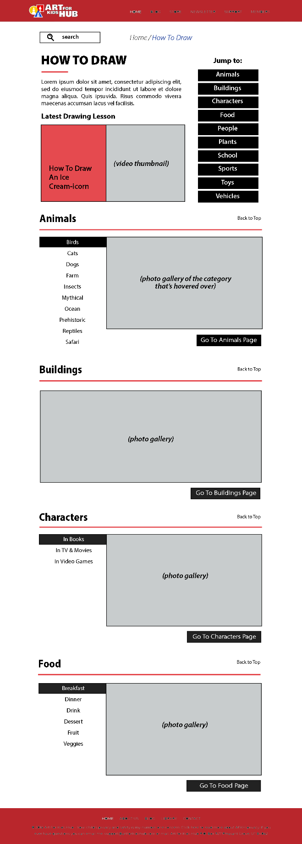
Multimedia Notes
- Background image for entire site is the black colored pencil/marker image
- Company logo at top left
- “Latest Art Lesson” section will vary based on the newest lesson posted. A thumbnail of the video will be in the gray rectangle
- As explained above, photo gallery for categories with subcategories will change based on the selected subcategory
- Photo gallery for categories without subcategories will just show an automatically moving slideshow of thumbnails for videos of drawing lessons for that category
- No narration, no audio

(Storyboard F) Category Main Page | Navigation Details  - Red home menu (at top & bottom) links to new pages  - Search bar at top left searches entire site  - Navigation text at top is clickable, (Home/ How To Draw/Animals) users can go back to home by clicking Home  - Clicking the Art For Kids Hub logo links back to Home page  - Black menu on right side contains clickable buttons for subcategories that when clicked, links users to its lessons gallery page  - The title of each section (birds, cats, dogs, farm, etc) can be clicked and links to its lessons gallery page  - Each section can be expanded or collapsed, so users have the potential to see all the subcategories completely expanded all at once (possibly nice feature to have for young children to browse by thumbnail image). When users click the “see more” button additional rows of video thumbnails appear, until all thumbnails of that category are shown. The “see more” button turns to “collapse” so that the category can be returned to only showing one row of thumbnails.  - Within each section, the titles of the video thumbnails will be color-coded based on their difficulty level (preschool, easy, medium, advanced). These levels can be filtered using the filter buttons at the top of each section. Users can disable a filter by clicking the “x” and it turns to a faded color. Video thumbnails of that color will disappear from the gallery view. They can be re-enabled by clicking on the button, and the color will return, indicating the filter is applied.  - “Back to Top” text at the top of each section can be clicked and brings user back to the top of the screen (to reduce scrolling)  - Clicking on the video thumbnail or anywhere on the its title will link users to the lesson page for that drawing lesson
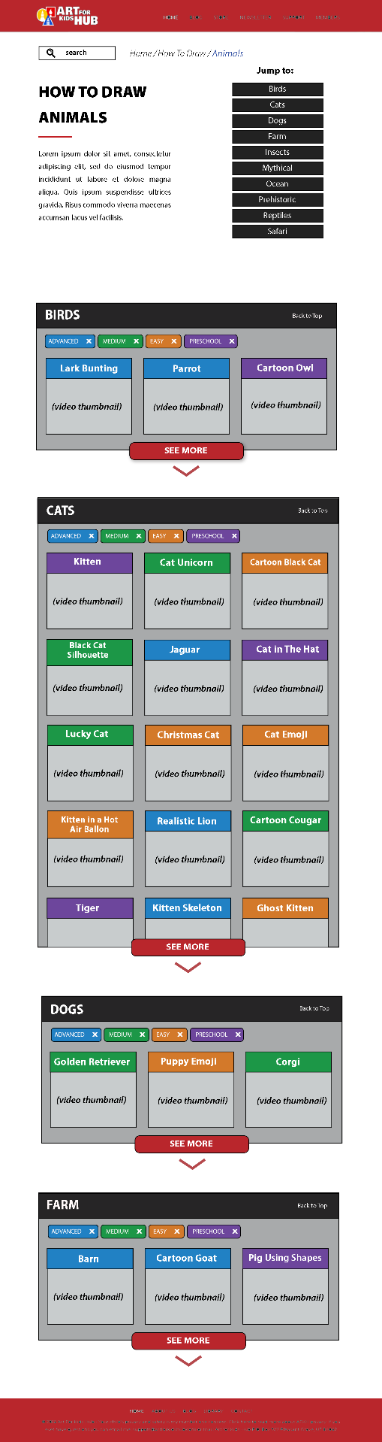

Multimedia Notes
- Background image for entire site is the black colored pencil/marker image
- Company logo at top left
- Each section starts by showing 3 thumbnails for videos of drawing lessons in that subcategory, and when users click “see more” additional rows of 3 thumbnails appear
- Each video thumbnail will have the red background cropped out, showing only the drawing result. The thumbnail will not contain the drawing lesson title; the title will be displayed above each thumbnail image using a plain font. The colored box behind the title for each video thumbnail will be color-coded based on its difficulty level (preschool, easy, medium, advanced)
- No narration, no audio
Pages with this Storyboard design:
How To Draw Animals
How To Draw Characters
How To Draw Food
Holiday Art Projects
Seasons

(Storyboard G) Lessons Gallery Page | Navigation Details  - Red home menu (at top & bottom) links to new pages  - Search bar at top left searches entire site  - Navigation text at top is clickable, (Home/ How To Draw/Animals/Cats) users can go back to home by clicking Home  - Clicking the Art For Kids Hub logo links back to Home page  - Each section can be expanded or collapsed, so users have the potential to see all levels completely expanded for browsing. When users click the “see more” button additional rows of video thumbnails appear, until all thumbnails of that category are shown. The “see more” button turns to “collapse” so that the category can be returned to only showing one row of thumbnails.  - Within each section, the titles of the video thumbnails will be white, unless they have a special tag (holidays, folding surprise, characters, etc). Titles with a tag will be color-coded with its filter button at the top of each section. Users can disable a filter by clicking the “x” and it turns to a faded color. Video thumbnails of that color will disappear from the gallery view. They can be re-enabled by clicking on the button, and the color will return, indicating the filter is applied.  - “Back to Top” text at the top of each section can be clicked and brings user back to the top of the screen (to reduce scrolling)  - Clicking on the video thumbnail or anywhere on the its title will link users to the lesson page for that drawing lesson
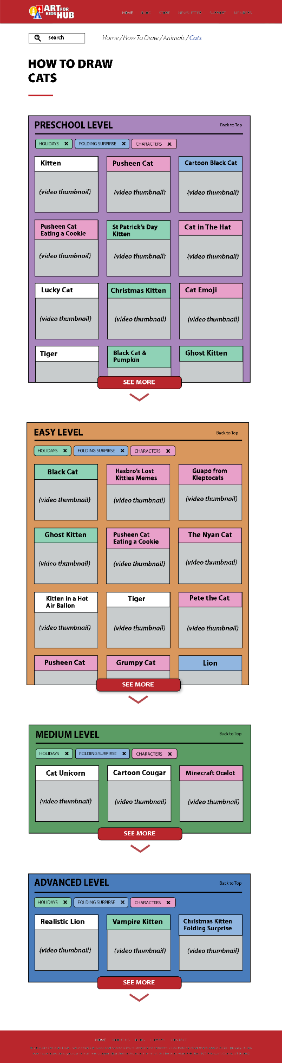

Multimedia Notes
- Background image for entire site is the black colored pencil/marker image
- Company logo at top left
- No narration, no audio
Pages with this Storyboard design:
How To Draw Animals: Cats
How To Draw Animals: Birds
How To Draw Animals: Dogs
How To Draw Animals: Farm
How To Draw Animals: Insects
How To Draw Animals: Mythical
How To Draw Animals: Ocean
How To Draw Animals: Prehistoric
How To Draw Animals: Reptile
How To Draw Animals: Safari
How To Draw Buildings
How To Draw Characters: In Books
How To Draw Characters: In TV & Movies
How To Draw Characters: In Video Games
How To Draw Food: Breakfast
How To Draw Food: Dinner
How To Draw Food: Drink
How To Draw Food: Dessert
How To Draw Food: Fruit
How To Draw Food: Veggies
How To Draw People
How To Draw Plants
How To Draw School
How To Draw Sports
How To Draw Toys
How To Draw Vehicles
Origami
Painting
Holiday Art Projects: Birthday
Holiday Art Projects: New Year’s Eve
Holiday Art Projects: Valentine’s Day
Holiday Art Projects: President’s Day
Holiday Art Projects: St Patrick’s Day
Holiday Art Projects: Easter
Holiday Art Projects: Earth Day
Holiday Art Projects: Cinco de Mayo
Holiday Art Projects: Mother’s Day
Holiday Art Projects: Memorial Day
Holiday Art Projects: Father’s Day
Holiday Art Projects: Fourth of July
Holiday Art Projects: Halloween
Holiday Art Projects: Veterans Day
Holiday Art Projects: Thanksgiving
Holiday Art Projects: Hanukkah
Holiday Art Projects: Christmas
Holiday Art Projects: Kwanzaa
Seasons: Spring
Seasons: Summer
Seasons: Autumn
Seasons: Winter

(Storyboard H) Lesson Page | Navigation Details  - Red home menu (at top & bottom) links to new pages  - Search bar at top left searches entire site  - Navigation text at top is clickable, (Home/How To Draw/Animals/Cats/Christmas Kitten Stack) users can go back to home by clicking Home, etc  - Clicking the Art For Kids Hub logo links back to Home page  - Learn more button links users to the “art supplies we love” page (current design OK)  - Clicking on the black video title will link users to a separate window for the video lesson on YouTube  - Clicking the play button on the YouTube video on the page will play the video at the thumbnail size  - Previous Lesson and Next Lesson buttons at the bottom when clicked, will take users to the previous and next lessons in the advanced cats category
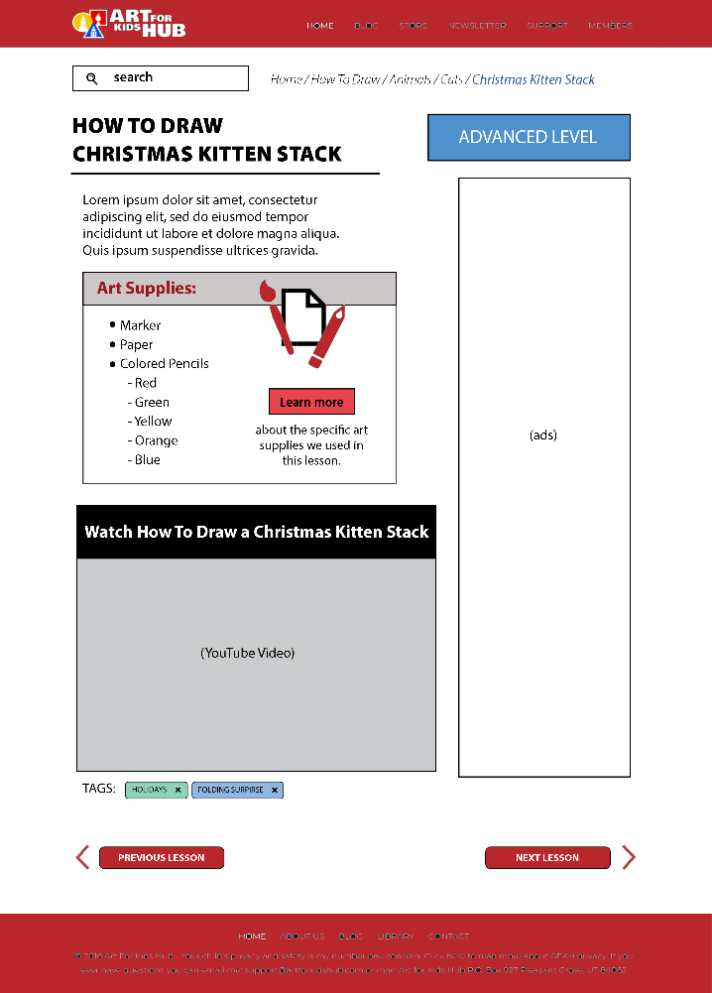
Multimedia Notes
- Background image for entire site is the black colored pencil/marker image
- Company logo at top left
- Audio and narration can be heard while the lesson plays at thumbnail size on the webpage

(Storyboard I) Page | Navigation Details  - Red home menu (at top & bottom) links to new pages  - Search bar at top left searches entire site
Multimedia Notes
- Background image for entire site is the black colored pencil/marker image

